
Sukkur Institute of Business Administration University
Department of Computer Science
BS – I (CS/SE) Fall 2025

Programming Fundamentals
Lab # 04: To become familiar with operators (Arithmetic, Increment, Decrement, sizeof ( ), Assignment, Relational and Logical)

Lab Report Rubrics  (Add the points in each column, then add across the bottom row to find the total score) |  |  |  |  | Total Marks
S.No | Criterion | 0.5 | 0.25 | 0.125
1 | Accuracy | - Desired output | - Minor mistakes | - Critical mistakes
2 | Timing | - Submitted within the given time | - 1 day late | - More than 1 day late
Submission Profile
Name: Submission date (dd/mm/yy):
Enrollment ID: Receiving authority name and signature:
Comments: __________________________________________________________________________
Instructor Signature

Note: Submit this lab hand-out in the next lab with attached solved activities and exercises

Objectives
After performing this lab, students will be able to
- Use Operators
- Arithmetic Operators
- Assignment Operator
- Relational Operators
- Logical Operator
- Increment Operators
- Decrement Operators
- sizeof() Operator

C++ Operators
An operator is a symbol used for performing operations on operands. Operands can be literal values or variables.
Consider the following operation:
a = x + y;
In the above statement, x and y are the operands while + is an addition operator. When the C++ compiler encounters the above statement, it will add x and y and store the result in variable a.
Operators in C++ can be classified into different types, like:
- Arithmetic Operators
- Assignment Operators
- Relational Operators
- Logical Operators
- Bitwise Operator

Arithmetic Operators
Arithmetic operators are used to perform arithmetic/mathematical operations on variables and data. For example: a + b;

Here, the + operator is used to add two variables a and b. Similarly, there are various other arithmetic operators in C++.

Operator | Operation
+ | Addition
- | Subtraction
* | Multiplication
/ | Division
% | Modulo Operation (gives remainder after division)

Example 1: Arithmetic Operators
#include <iostream>
using namespace std;
int main() {
int a, b;
a = 7;
b = 2;
// printing the sum of a and b
cout << "a + b = " << (a + b) << endl;

// printing the difference of a and b
cout << "a - b = " << (a - b) << endl;

// printing the product of a and b
cout << "a * b = " << (a * b) << endl;
// printing the division of a by b
cout << "a / b = " << (a / b) << endl;
// printing the modulo of a by b
cout << "a % b = " << (a % b) << endl;
return 0;}

Output
a + b = 9
a - b = 5
a * b = 14
a / b = 3
a % b = 1
Here, the operators +, - and * compute addition, subtraction, and multiplication respectively as we might have expected.

A note about the division operator /
Note the operation (a / b) in our program. The / operator is the division operator. As we can see from the above example, if an integer is divided by another integer, we will get the quotient.
However, if either divisor or dividend is a floating-point number, we will get the result in decimals.
In C++
7/2 is 3
7.0 / 2 is 3.5
7 / 2.0 is 3.5
7.0 / 2.0 is 3.5

% Modulo Operator
The modulo operator % computes the remainder. When a = 9 is divided by b = 4, the remainder is 1.
Note: The % operator can only be used with integers.

Assignment Operators
In C++, assignment operators are used to assign values to variables. For example,
a = 5; // assign 5 to a
Here, we have assigned a value of 5 to the variable a.
The arithmetic operators and assignment operator can also be used in the following ways:

Operator | Example | Equivalent to
= | a = b; | a = b;
+= | a += b; | a = a + b;
-= | a -= b; | a = a - b;
*= | a *= b; | a = a * b;
/= | a /= b; | a = a / b;
%= | a %= b; | a = a % b;

Example: Assignment Operators

#include <iostream>
using namespace std;

int main()
{
int a, b, temp;

// 2 is assigned to a
a = 2;
// 7 is assigned to b
b = 7;
// value of a is assigned to temp
temp = a; // temp will be 2

cout << "temp = " << temp << endl;
// assigning the sum of a and b to a
a += b; // a = a +b

cout << "a = " << a << endl;
return 0;
}

Output
temp = 2
a = 9

Relational Operators
A relational operator is used to check the relationship between two operands. For example, you may need to know which operand is greater than the other, or less than the other. Therefore, these are also called comparison operators, sometimes. Their result is a Boolean value (true or false). For example,
// checks if a is greater than b
a > b;
Here, > is a relational operator. It checks if a is greater than b or not. If the relation is true, it returns true (or 1) whereas if the relation is false, it returns false (or 0).
Note: In C++, a Boolean false is also denoted by a 0 and a Boolean true is represented with a value greater than or equal to 1.

Operator | Meaning | Example
== | Is Equal To | 3 == 5 gives us false
!= | Not Equal To | 3 != 5 gives us true
> | Greater Than | 3 > 5 gives us false
< | Less Than | 3 < 5 gives us true
>= | Greater Than or Equal To | 3 >= 5 give us false
<= | Less Than or Equal To | 3 <= 5 gives us true

Example: Relational Operators
#include <iostream>
using namespace std;
int main() {
int a, b; a = 3;
b = 5;
bool result;
result = (a == b); // false
cout << “3 == 5 is “ << result << endl;

Output
3 == 5 is 0
3 != 5 is 1
3 > 5 is 0
3 < 5 is 1
3 >= 5 is 0
3 <= 5 is 1

result = (a != b); // true
cout << “3 != 5 is “ << result << endl;
result = a > b; // false
cout << “3 > 5 is “ << result << endl;
result = a < b; // true
cout << “3 < 5 is “ << result << endl;
result = a >= b; // false
cout << “3 >= 5 is “ << result << endl;
result = a <= b; // true
cout << “3 <= 5 is “ << result << endl;
return 0;}
Note: Relational operators are mostly used in decision-making and loops.

Logical Operators
Logical operators are used to check whether an expression is true or false. OR
The logical operators check two or more conditions and return a Boolean value (true/false). In C++, there are three logical operators
- Logical AND operator (denoted by &&)
- Logical OR operator (denoted by ||)
- Logical NOT operator (denoted by !)

Operator | Description
&& logical AND operator | The condition is true if both operands are non-zero (not false).
|| logical OR operator | The condition is true if one of the operands is non-zero (not false).
! logical NOT operator | It reverses operand’s logical state. If the operand is true, the !  operator makes it false and vice versa.

Logical Operator AND: &&
The logical AND operator is denoted by &&. It returns true if the condition on the left and the condition on the right are both true. Otherwise, it returns false. Here’s its truth table:

a | b | a && b
false | false | false
false | true | false
true | false | false
true | true | true
For instance:
- ( 1 < 2 && 2 < 3 ) returns true
- ( 1 < 2 && 2 > 3 ) returns false

Logical Operator OR: II
The logical OR operator is denoted by ||. It returns true when the condition on the left is true or the condition on the right is true. Only one of them needs to be true. Here’s its truth table:

a | B | a || b
false | False | false
false | True | true
true | False | true
true | True | true
For instance:
- ( 1 < 2 || 2 > 3 ) returns true
- ( 1 > 2 || 2 > 3 ) returns false

Logical Operator NOT: !
The logical NOT operator is denoted by “!”. It reverses the bool outcome of the expression that immediately follows. Here’s its truth table:

A | !a
false | true
true | false
For instance:
- ( !true ) returns false
- ( !false ) returns true
- ( !(10 < 11) ) returns false
Examples:
a = 5
b = 8 Then,
(a > 3) && (b > 5) evaluates to true
(a > 3) && (b < 5) evaluates to false
(a > 3) || (b > 5) evaluates to true
(a > 3) || (b < 5) evaluates to true
(a < 3) || (b < 5) evaluates to false
!(a == 3) evaluates to true
!(a > 3) evaluates to false

Example: Logical Operators
#include <iostream>
using namespace std;
int main()
{
bool result;
result = (3 != 5) && (3 < 5); // true
cout << "(3 != 5) && (3 < 5) is " << result << endl;
result = (3 == 5) && (3 < 5); // false
cout << "(3 == 5) && (3 < 5) is " << result << endl;
result = (3 == 5) && (3 > 5); // false
cout << "(3 == 5) && (3 > 5) is " << result << endl;
result = (3 != 5) || (3 < 5); // true
cout << "(3 != 5) || (3 < 5) is " << result << endl;
result = (3 != 5) || (3 > 5); // true
cout << "(3 != 5) || (3 > 5) is " << result << endl;
result = (3 == 5) || (3 > 5); // false
cout << "(3 == 5) || (3 > 5) is " << result << endl;
result = !(5 == 2); // true
cout << "!(5 == 2) is " << result << endl;
result = !(5 == 5); // false
cout << "!(5 == 5) is " << result << endl;
return 0;
}

Output
(3 != 5) && (3 < 5) is 1
(3 == 5) && (3 < 5) is 0
(3 == 5) && (3 > 5) is 0
(3 != 5) || (3 < 5) is 1
(3 != 5) || (3 > 5) is 1
(3 == 5) || (3 < 5) is 0
!(5 == 2) is 1
!(5 == 5) is 0

Explanation of logical operator program
- (3 != 5) && (3 < 5) evaluates to 1 because both operands (3 != 5) and (3 < 5) are 1 (true).
- (3 == 5) && (3 < 5) evaluates to 0 because the operand (3 == 5) is 0 (false).
- (3 == 5) && (3 > 5) evaluates to 0 because both operands (3 == 5) and (3 > 5) are 0 (false).
- (3 != 5) || (3 < 5) evaluates to 1 because both operands (3 != 5) and (3 < 5) are 1 (true).
- (3 != 5) || (3 > 5) evaluates to 1 because the operand (3 != 5) is 1 (true).
- (3 == 5) || (3 > 5) evaluates to 0 because both operands (3 == 5) and (3 > 5) are 0 (false).
- !(5 == 2) evaluates to 1 because the operand (5 == 2) is 0 (false).
- !(5 == 5) evaluates to 0 because the operand (5 == 5) is 1 (true).

Increment and Decrement Operators
C++ also provides increment and decrement operators: ++ and --, respectively. ++ increases the value of the operand by 1, while -- decreases it by 1. For example,
int num = 5;
// increasing num by 1
++num;
Here, the value of num gets increased to 6 from its initial value of 5.
Increment/decrement operators work in two ways: prefix increment and postfix increment.

Operator | Symbol | Form | Operation
Prefix increment (pre-  increment) | ++ | ++x | Increment x, then return x
Prefix decrement (pre decrement) | – – | – –x | Decrement x, then return x
Postfix increment (post  increment) | ++ | x++ | Copy x, then increment x, then return the copy
Postfix decrement (post  decrement) | – – | x– – | Copy x, then decrement x, then return the copy
Note that there are two versions of each operator -- a prefix version (where the operator comes before the operand) and a postfix version (where the operator comes after the operand).
The prefix increment/decrement operators are very straightforward. First, the operand is incremented or decremented, and then expression evaluates to the value of the operand.
For example:

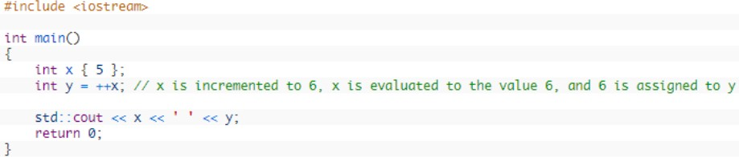

This will print 6 6

The postfix increment/decrement operators are trickier. First, a copy of the operand is made. Then the operand (not the copy) is incremented or decremented. Finally, the copy (not the original) is evaluated. For example:
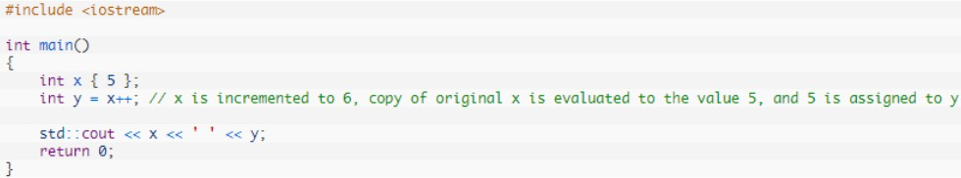
This will print 6 5
Let’s examine how this (y = x++) works in more detail.
First, a temporary copy of x is made that starts with the same value as x (5). Then the actual x is incremented from 5 to 6. Then the copy of x (which still has value 5) is returned and assigned to
y. Then the temporary copy is discarded.
Consequently, y ends up with the value of 5 (the pre-incremented value), and x ends up with the value 6 (the post-incremented value).
Note: The postfix version takes a lot more steps, and thus may not be as performer as the prefix version.
Here is another example showing the difference between the prefix and postfix versions:

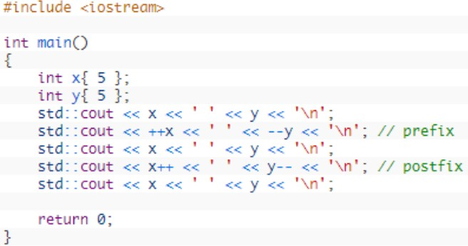
This produces the output:
5 | 5
6 | 4
6 | 4
6 | 4
7 | 3
On the line where we have ++x and --y, we do a prefix increment and decrement. On this line, x and y are incremented/decremented before their values are sent to std::cout, so we see their updated values reflected by std::cout.
On the 10th line where we have x++ and y--, we do a postfix increment and decrement. On this line, the copy of x and y (with the pre-incremented and pre-decremented values) are what is sent to std::cout, so we don’t see the increment and decrement reflected here. Those changes don’t show up until the next line, when x and y are evaluated again.

sizeof ( ) Operator:

This operator is used to return the size of the operand in bytes. For example, the int data type in C++ has a 4 bytes size. The sizeof() operator will return this value. The sizeof() operator is used as a function in the program. The variable type and the amount of memory required to store the value are shown in the table below. The values shown here may differ from one compiler to another.

Syntax

sizeof(data_variable);

Example Here is a program to demonstrate the use of the sizeof( ) operator.

#include <iostream>

using namespace std;

int main()

{ int x = 5;

double y = 12.43;

cout << " Size of x = " << sizeof(x) << endl;

cout << " Size of y = " << sizeof(y) << endl;

return 0;}

Output

Size of x = 4

Size of y = 8

Practice Task 1

Write a program in which you declare and initialize all the countable and measurable datatypes provided by dev-C++ compiler. Moreover, you are required to print the minimum and maximum range of values that can be stored in those variables along with the space occupied by those variables in the memory.

Solution:

#include <iostream>

using namespace std ;

int main ()

{

short s1 = 10 ;

signed short s2 = 20 ;

unsigned short s3 = 30 ;

int i1 = 10 ;

signed int i2 = 20 ;

unsigned int i3 = 30 ;

long l1 = 10 ;

signed long l2 = 20 ;

unsigned long l3 = 30 ;

long long ll1 = 10 ;

signed long long ll2 = 20 ;

unsigned long long ll3 = 30 ;

float f = 9.123456789 ;

double d = 9.123456789000000 ;

long double ld = 9.1234567890000000000 ;

cout << "\n\n Check the upper and lower limits of countable datatypes :\n";

cout << " \n";

cout << " The maximum limit of int data type : " << INT_MAX << endl;

cout << " The minimum limit of int data type : " << INT_MIN << endl;

cout << " The maximum limit of unsigned int data type : " << UINT_MAX << endl;

cout << " The maximum limit of long long data type : " << LLONG_MAX << endl;

cout << " The minimum limit of long long data type : " << LLONG_MIN << endl;

cout << " The maximum limit of unsigned long long data type: " << ULLONG_MAX << endl;

cout << " The minimum limit of short data type : " << SHRT_MIN << endl;

cout << " The maximum limit of short data type : " << SHRT_MAX << endl;

cout << " The maximum limit of unsigned short data type : " << USHRT_MAX << endl;

cout << " The minimum limit of float data type : " << FLT_MIN << endl;

cout << " The maximum limit of float data type : " << FLT_MAX << endl;

cout << " The minimum limit of double data type : " << DBL_MIN << endl;

cout << " The maximum limit of double data type : " << DBL_MAX << endl;

cout << " The minimum limit of long double data type : " << LDBL_MIN << endl;

cout << " The maximum limit of long double data type : " << LDBL_MAX << endl;

cout << endl;

cout << "\n\n Check the space of memory occupied by countable datatypes :\n";

cout <<"The s1 size in memory = " <<sizeof (s1) <<endl;

cout <<"The s2 size in memory = " <<sizeof (s2) <<endl;

cout <<"The s3 size in memory = " <<sizeof (s3) <<endl;

cout <<"The i1 size in memory = " <<sizeof (i1) <<endl;

cout <<"The i2 size in memory = " <<sizeof (i2) <<endl;

cout <<"The i3 size in memory = " <<sizeof (i3) <<endl;

cout <<"The l1 size in memory = " <<sizeof (l1) <<endl;

cout <<"The l2 size in memory = " <<sizeof (l2) <<endl;

cout <<"The l3 size in memory = " <<sizeof (l3) <<endl;

cout <<"The ll1 size in memory = " <<sizeof (ll1) <<endl;

cout <<"The ll2 size in memory = " <<sizeof (ll2) <<endl;

cout <<"The ll3 size in memory = " <<sizeof (ll3) <<endl;

cout <<"The f size in memory = " <<sizeof (f) <<endl;

cout <<"The d size in memory = " <<sizeof (d) <<endl;

cout <<"The ld size in memory = " <<sizeof (ld) <<endl;

return 0 ;

}

Practice Task: 2
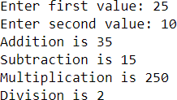
Write a C++ program that asks user to input two integer values and then performs the addition, subtraction, multiplication, and division on those values. Something like shown below:

Solution
#include <iostream>
using namespace std;
int main() {
int num1;
int num2;
cout << "Enter first number: ";
cin >> num1;
cout << "Enter second number: ";
cin >> num2;
cout << "Addition is " << num1+num2 << endl;
cout << "Subtraction is " << num1-num2 << endl;
cout << "Multiplication is " << num1*num2 << endl;
cout << "Division is " <<num1/num2 << endl;
return 0;}

Practice Task: 3
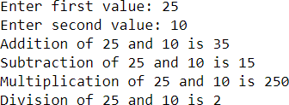
Make some changes in the program written in the Activity above so that the output should be like the following:
#include <iostream>
using namespace std;
int main() {
int num1, num2;
cout << "Enter first number: ";
cin >> num1;
cout << "Enter second number: ";
cin >> num2; endl;
cout << "Addition of " << num1 << " and " << num2 << " is " << num1+num2 << endl;
cout << "Subtraction of " << num1 << " and " << num2 << " is " << num1-num2 << endl;
cout << "Multiplication of " << num1 << " and " << num2 << " is " << num1*num2 <<endl;
cout << "Division of " << num1 << " and " << num2 << " is " << num1/num2 << endl;
return 0;}

Exercises

- Length and breadth of a rectangle are 5 and 7 respectively. Write a program to calculate the area and perimeter of the rectangle.

- Write a program that inputs a six-digit integer, separates the integer into its individual digits and prints the digits vertically using modulus operator. For example, if the user types 953647, the program should print:
7
4
6
3
5
9

- Write a program to convert Fahrenheit into Celsius.
$$C= \frac{5}{9} ( F-32)$$

- Write a program that finds the value of X by using given formula. Take value of ‘a’ and ‘b’ from user.
X = 5ab ( a + b ) – 3ab

- Write a program that takes two numbers from user and checks if the two numbers are equal or not by returning 1 or 0 respectively.

- Write a program to enter the values of two variables 'a' and 'b' from user and then check if both the conditions 'a < 50' and 'a < b' are true.

- Write a program to enter the values of two variables 'a' and 'b' from user and then check if atleast one of the conditions 'a < 50' and 'a < b' is true.

- Implement a program that calculates the square of a number entered by the user (using assignment operator).

